**ASSIGNMENT-II**

**RESONANCE**

1. An RLC series circuit has R=100 Ω, L=500 mH & C=40 µF. Calculate the resonant, lower & upper half power frequency.
2. Show that for an RLC series circuit resonant frequency Wo = √ (w1 w2), where w1 and w2 are lower & upper half power frequency respectively.
3. Show that for a RLC series circuit

Qo = Wo L / R = fo /BW = 1/(WoRC)

1. 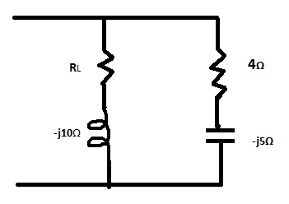An RLC series circuit has R=50 Ω, L=0.05H, & C=20 µF. Voltage applied to this circuit is 200V with variable frequency. Find
2. the maximum capacitor voltage & frequency at which it occurs, and
3. the maximum voltage across inductor & frequency at which it occurs.
4. Find the value of RL for which the circuit in Fig.1 is in resonance.

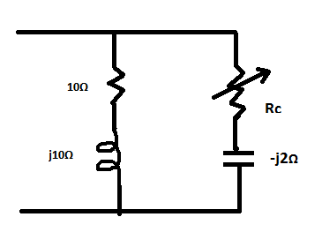 Fig.1

1. Determine the value of Rc in Fig.2 to yield resonance.

Fig.2

1. Two identical coils each of 5 ohm resistor are mounted coaxially. When one coil is supplied with 100V, 50 Hz the current taken is 10.5A and emf induced in the other coil on open circuit is 54V.

a) Calculate self and mutual inductance between them.

b) What will be the current taken by the two coils when connected in series across 100V, 50 Hz supply.

1. Two coils having resistance of 1.5 Ω and 5 Ω ohm and self-inductance of 5H and 20H respectively have the mutual inductance of 9.8H. One coil is connected to 100V, 50 Hz supply. Find
2. Primary current and secondary voltage, second terminals being open circuit
3. Primary current and secondary current, Second terminal being short circuited
4. Two circuits each comprising a series connection of inductance 300 µH and capacitance of 1000 µF are coupled with a mutual inductance of 60 µH. An emf of 10 V at 1/π MHz is injected into one circuited. Calculate the current in the other circuit when its terminal is shorted and the co-efficient of coupling.
5. Two coils A(R1=50 Ω , L1=0.2H) and B(R2= 200 Ω,L2=0.5 H) are the coupled by a mutual inductance of 0.25H.Find the voltage at a frequency of 1000/2π Hz that must be maintained across the terminals of A in Order that a current of 10 mA may flow in B, when terminal of B are connected to a resistance of 50 Ω.